REGISTRATION DETAILS FOR COMPLETE RECORD 2022:

Entity Name: J.W. Pepper & Son Inc.
DUNS Number: 014783302
CAGE: 86470

Address:
191 Sheree Blvd
Exton, PA 19341-1265
United States

Purpose of Registration: All Awards
Registration Status: Active
Expiration Date: 3/11/23

Link for verified vendor seal for 2022:
<a href=https://usfcr.com><img src=https://usfcr.com/assets/img/Verified-Vendor-Seal-2022-sm.png alt="USFCR Verified Vendor" title="US Federal Contractor Registration System for Award Management Verified Vendor Seal"></a>

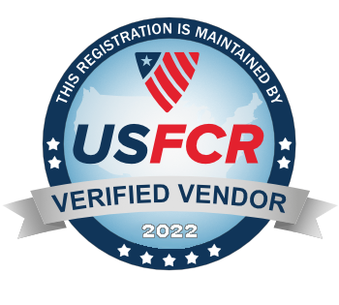

Customers can go to the SAM website, enter our CAGE code and they can verify that we are an active member of SAM:
https://sam.gov/content/home

